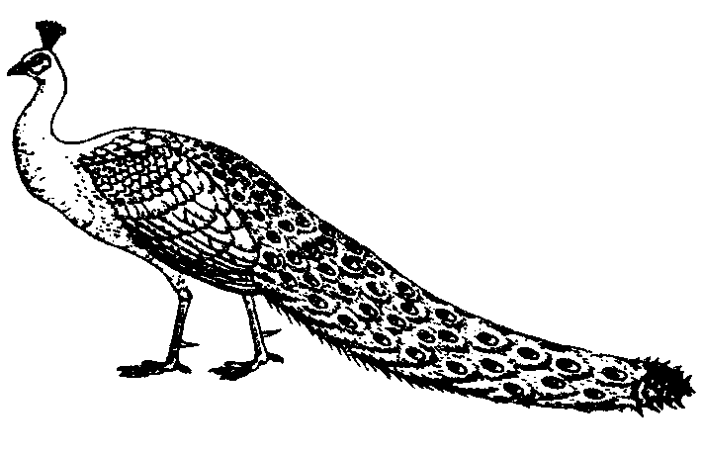

Hopkins’ Alternative Livestock
www.hopkinslivestock.com
Craig & Lisa Hopkins

1479 North Washington Road Greens Fork, IN 47345-9771
(765) 886-5560 PeacockBirdman@aol.com

Peafowl Medications

The following information has been gathered over many years of raising peafowl. Use this information with the understanding that most of these medications are not labeled for use on peafowl. This information is provided as a resource for treating peafowl with different kinds of ailments.

Wormers: To break the life cycle of the parasites, repeat the worming process in 10 days.

Ivermectin for cattle (brown box). Ivermectin will kill all internal and any blood sucking parasite.

½ cc (bird over 1 year) given as shot under the skin or as drench down the throat.
2/10 cc (bird under 1 year) as an injection under the skin or as a drench.
3 cc per gallon of drinking water.
¼ cc (bird over 1 year) given as an injection under the skin in the scruff of the neck between the shoulder blades.

Tramisol drench for sheep (a 13 gm. packet). Tramisol will kill most all of the internal parasites.

Mix one packet of Tramisol in one quart of water.
Mix 1oz. (2 tablespoons) of this solution per gallon of drinking water.

Levasole for hogs (a 500 ml plastic bottle). Levasole will kill most all of the internal parasites.

Fill the plastic bottle of Levasole with water and shake up thoroughly.
Mix 1 teaspoon of this solution per gallon of drinking water.
If you don’t want to use the entire bottle of wormer at one time, follow these directions.
Mix ¼ teaspoon of the powder from the bottle per gallon of drinking water.

Levasole drench for cattle and sheep (52 gm. packet). Levasole is very effective wormer.

Mix 1, packet of Levasole with one gallon of drinking water.
Mix 1 oz. (2 tablespoons) of this solution per gallon of drinking water.

Panacur (Fenbendazole) Horse and cattle dewormer. Suspension 10%. 100mg/mL

3 cc per gallon of drinking water for 2 or 3 days.
1 cc (bird over 1 year) as a drench down the throat for 3 days.
½ cc (bird between 3 mo. and 1 year) as drench down the throat for 3 days.

Safe-Guard Cattle Drench (Fenbendazole) Suspension 10%. 100mg/mL. 1000 mL.

3 cc per gallon of drinking water for 2 or 3 days. Can repeat again in 10 days.

Antibiotics:

Tylan 200 for cattle. Tylan 200 has proven to be an excellent antibiotic for peafowl.
Tylan 200 is especially affective for treating peafowl with swollen eye sinuses.
Tylan 200 is an intramuscular injection.

1-2 cc as a shot in the leg or the breast muscle for birds over 1 year old.
½-1 cc as a shot in the leg or the breast muscle for birds under 1 year old.

Tylan powder (100 g): Tylan powder is a good antibiotic for respiratory illnesses in peafowl.

Mix 1 ½ teaspoons of Tylan powder into 1 gallon of water and mix thoroughly.
Mix this solution with 5 gallons of drinking water.

Baytril Baytril is especially affective for treating peafowl with swollen eye sinuses.
Baytril is available in tablets, liquid, and injectable form.

Tablets: 5.7 mg, 22.7mg, or 68 mg concentration. Desired dose is 32.3 mg/mL.

Crush 2, 22.7 mg tablets per quart of drinking water. Medicate birds for 3 days.
Crush 3, 68 mg tablets per gallon of drinking water.
or
Administer 1, 22.7 mg tablet orally to each adult bird for 3 days.

Liquid: Concentration is 32.3 mg/mL. Desired dose is 50 ppm.

Mix 1 oz. per 5 gallons of drinking water. Medicate birds for 3 days.
Mix 6 cc per 1 gallon of drinking water. Medicate birds for 3 days.

Injectable: Baytril is an intramuscular injection. Concentration is 22.7 mg/mL.
Desired dose is 1.13 mg/lb = 0.05 cc/lb.

Adult peafowl (1+ year): Give 1/2 cc injection in the leg or breast muscle.
Peachicks: Give injection based on body weight of peachick in the leg or breast muscle.

Corid. Corid is used to treat coccidiosis in peafowl.

Mix 1 teaspoon per gallon of drinking water. Medicate birds 4 to 5 days.

Sulmet powder: Sulmet is used to treat coccidiosis in peafowl.

Mix 2 tablespoons per gallon of drinking water. Medicate first 2 days with this dosage.
Mix 1 tablespoon per gallon of drinking water. Medicate for 4 additional days with this dosage.

NFZ puffer for cattle. This product is good for eye problems in peafowl.

“Puff “directly into the eye with the eyelids held open.

Flagel Flagel is used to treat Blackhead in peafowl.

Flagel has to be proscribed by a veterinarian.

Aureomycin soluble powder. Chlortetracycline. Treats respiratory diseases and Infectious Synovitis.

Peafowl over 1 year: Mix 2 measuring teaspoons/gal. drinking water. Medicate 7 to 14 days.
Peachicks over 6 months: Mix 1 to 2 teaspoons/gal. drinking water. Medicate 7 to 14 days.
Peachicks under 6 months: Mix ½ to 1 teaspoon/gal. drinking water. Medicate 7 to 14 days.

Other useful products:

Scalex Mite and Lice Spray for birds:

Lightly spray birds under the wings, over the back, on the chest and belly, and around vent.

Tektrol disinfectant:

Use per the label. Use to disinfect hatchers, incubators, feed containers, waterers, and etc.

Measuring units:

Liquids:

1 fluid ounce (oz.) = 2 tablespoons = 30 cc = 30mL
1 milliliter (mL) = 1 cc, 1,000 cc = 1 L
1 teaspoon = 5cc
1 tablespoon = 15cc
8 oz. = 1 cup, 2 cups = 1pint, 2 pints = 1 quart, 4 quarts = 1 gallon

Dry powders:

1 ounce (oz.) = 3 ½ measuring tablespoons
1 tablespoon = 3 teaspoons

Most of these products can be purchased through the following companies.

Cutler’s Supply, Inc. Jeffers
1940 Old 51 P.O. Box 100
Applegate, MI 48401 Dothan, AL 36301-0100
Phone: 810-633-9450 Phone: 800-533-3377
E-mail: Cutlers@greatlakes.net www.jefferslivestock.com
www.cutlersupply.com

